**CC4057 Introduction to Information Systems**

**Lab work – week 4**

1. Create a database named ***movie_rental***.
2. Create the following tables in the database

***genres***

|  |  |  |
| --- | --- | --- |
| genreID | INT | PRIMARY KEY, AUTO_INCREMENT |
| name | VARCHAR(20) | NOT NULL |
|  |  |  |

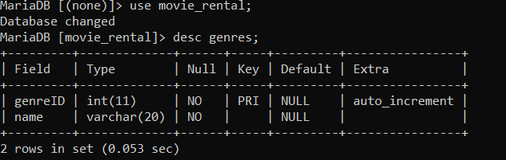

***movies***

|  |  |  |
| --- | --- | --- |
| movieID | INT | PRIMARY KEY, AUTO_INCREMENT |
| name | VARCHAR(30) | NOT NULL |
| releaseDate | DATE | NOT NULL |
| genre | INT | FOREIGN KEY, NOT NULL |
| pricePerDay | INT | NOT NULL |

*The foreign key ***genre*** references to the ***genreID*** column in the ***genres*** table

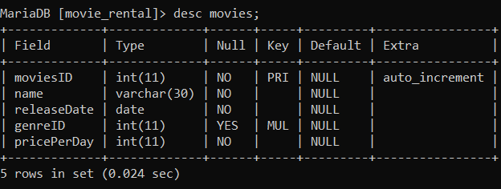

***clients***

|  |  |  |
| --- | --- | --- |
| clientID | INT | PRIMARY KEY, AUTO_INCREMENT |
| firstName | VARCHAR(20) | NOT NULL |
| lastName | VARCHAR(20) |  |
| dob | DATE |  |
| phone | VARCHAR(20) | NOT NULL |

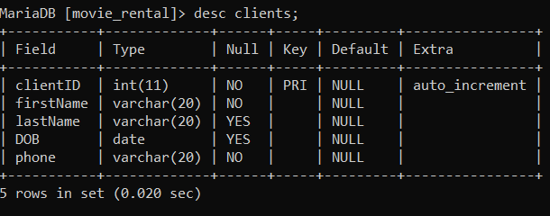

***rents***

|  |  |  |
| --- | --- | --- |
| rentID | INT | PRIMARY KEY |
| movie | INT | FOREIGN KEY, NOT NULL |
| client | INT | FOREIGN KEY, NOT NULL |
| startDate | DATE | NOT NULL |
| endDate | DATE | NOT NULL |

*The foreign key ***movie*** references to the ***movieID*** column in the ***movies*** table, and foreign key ***client*** references to the ***clientID*** column in the ***clients*** table

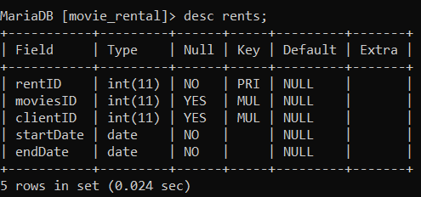

1. Insert the following data into the tables

***genres***

|  |  |
| --- | --- |
| *genreID* | *name* |
| 1 | Action |
| 2 | Comedy |
| 3 | Horror |
| 4 | Animation |
| 5 | Musical |

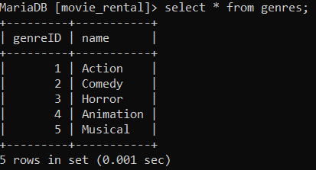

***movies***

|  |  |  |  |  |
| --- | --- | --- | --- | --- |
| *movieID* | *name* | *releaseDate* | *genre* | *pricePerDay* |
| 1 | Logan | 2017-12-05 | 1 | 200 |
| 2 | Star Wars | 1990-01-07 | 1 | 150 |
| 3 | Conjuring | 2015-06-04 | 3 | 175 |
| 4 | Grudge | 2012-11-03 | 3 | 140 |
| 5 | Mr Bean | 1994-05-12 | 2 | 200 |
| 6 | Kung Fu Panda | 2009-12-21 | 2 | 160 |
| 7 | Lion King | 1994-06-22 | 4 | 250 |
| 8 | August Rush | 2009-08-14 | 5 | 160 |
| 9 | School Of Rock | 1997-06-22 | 5 | 300 |
| 10 | Transformers | 2014-06-12 | 1 | 275 |

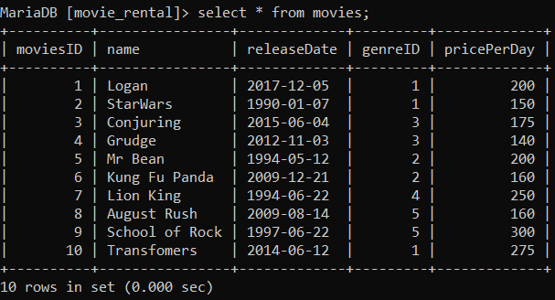

***clients***

|  |  |  |  |  |
| --- | --- | --- | --- | --- |
| *clientID* | *firstName* | *lastName* | *dob* | *phone* |
| 1 | Mark | Guiliana | 1989-09-12 | 122-555-888 |
| 2 | Benny | Greb | 1985-04-04 | 545-862-745 |
| 3 | Mark | Twain | 1990-07-22 | 541-965-785 |
| 4 | Anna | Ivanovna | 1994-09-12 | 654-785-022 |
| 5 | Kate | Bengio | 2000-12-01 | 854-885-446 |
| 6 | Siraj | Rawal | 1991-04-18 | 854-889-886 |
| 7 | James | Arthur | 1989-06-24 | 654-852-962 |

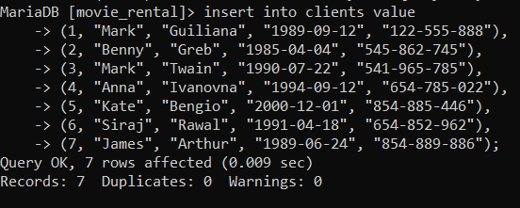

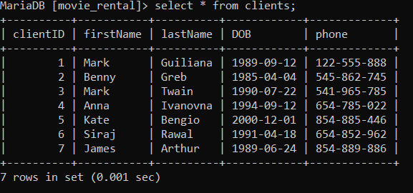

***rents***

|  |  |  |  |  |
| --- | --- | --- | --- | --- |
| *rentID* | *movie* | *client* | *startDate* | *endDate* |
| 1 | 1 | 3 | 2017-02-12 | 2017-02-17 |
| 2 | 2 | 3 | 2017-02-12 | 2017-02-17 |
| 3 | 10 | 1 | 2017-02-19 | 2017-02-22 |
| 4 | 4 | 1 | 2017-02-22 | 2017-02-27 |
| 5 | 2 | 2 | 2017-02-26 | 2017-03-01 |
| 6 | 3 | 4 | 2017-03-01 | 2017-03-06 |
| 7 | 8 | 5 | 2017-03-12 | 2017-03-15 |
| 8 | 4 | 7 | 2017-03-19 | 2017-03-22 |
| 9 | 5 | 6 | 2017-03-21 | 2017-03-25 |
| 10 | 9 | 6 | 2017-03-22 | 2017-03-26 |

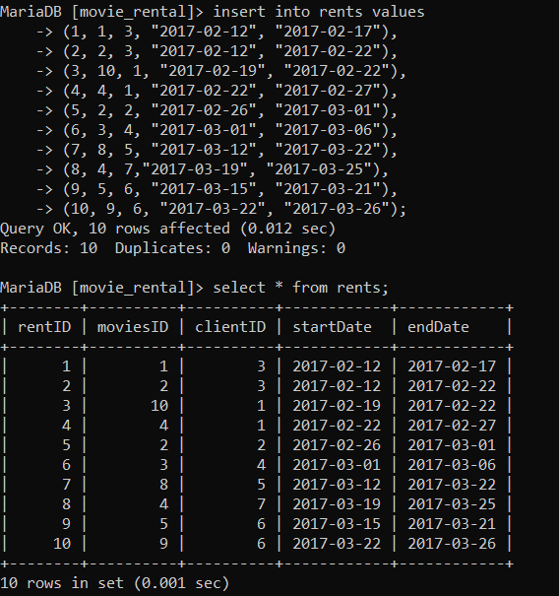

1. Write SQL statements for doing the following:
   1. Show all the details of the clients whose names begin with “m”.

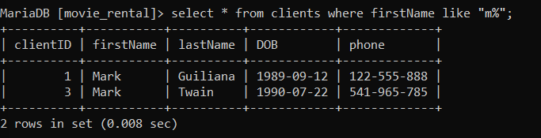

* 1. Show the lastName and dob of the clients whose last names end in “a” or ”o”.

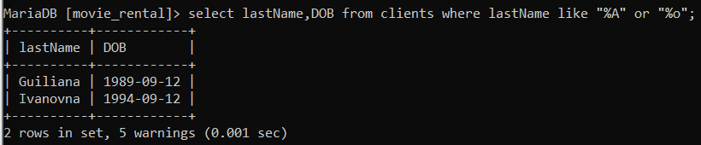

* 1. Show all the details of the movies which were released in the 90s.

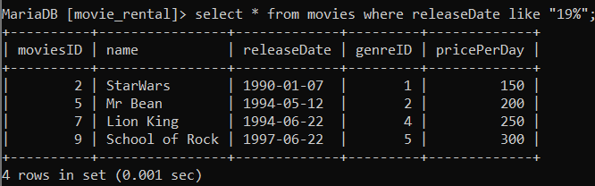

* 1. Show all the details of the clients who were born in September or April.

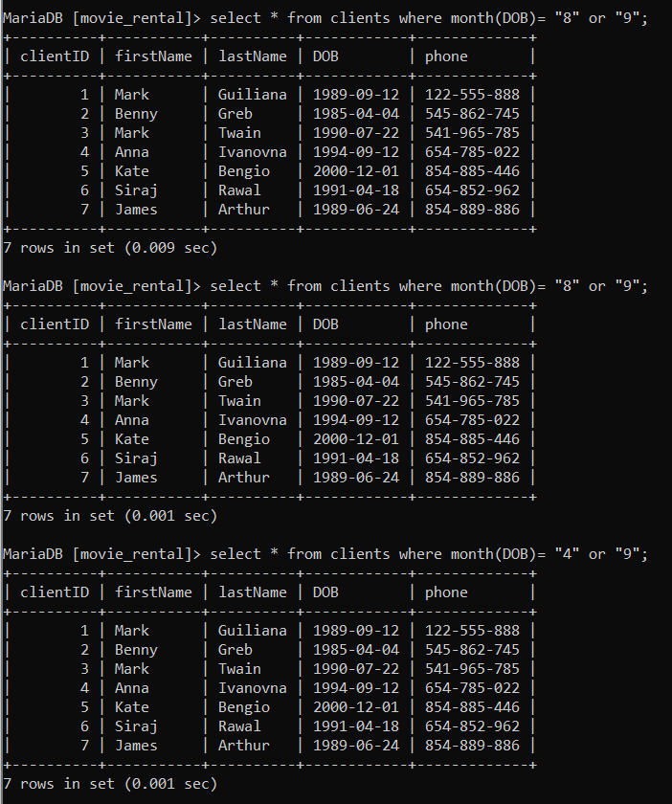

* 1. Show all the details of the Action and Horror movies.

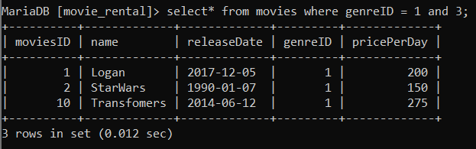

* 1. Show the average pricePerDay of the movies.